**Project Name :** Job Application Tracking System - (Developer) - (Shortterm)

# Team Details :

**Team ID : LTVIP2023TMID11621**

# Team Leader : V MOHAN KUMAR

**Creation Of Jobs Object**

Click on the gear icon and then select Setup.

1. Click on the object manager tab just beside the home tab.
2. After the above steps, have a look on the extreme right you will find a Create Dropdown click on that and select Custom Object.
3. On the Custom Object Definition page, create the object as follows:
   * Label: Job
   * Plural Label: Jobs
   * Record Name: Job Name
   * Select the data type as "Text".
   * Check the Allow Reports checkbox
   * Check the Allow Search checkbox
   * In the Object Creation Options section, select Add Notes and Attachments related list to default page layout
   * Click Save.

# Creation Of Candidate Object

1. Click on the gear icon and then select Setup.
2. Click on the object manager tab just beside the home tab.
3. After the above steps, have a look on the extreme right you will find a Create Dropdown click on that and select Custom Object.
   * On the Custom Object Definition page, create the object as follows:
   * Label: Candidate
   * Plural Label: Candidates
   * Record Name: Candidates Name
   * Select the data type as "Text".
   * Check the Allow Reports checkbox.
   * Check the Allow Search checkbox.
   * In the Object Creation Options section, select Add Notes and Attachments related list to default page layout.
   * Click Save.

# Creation Of Job Application Object

* + Click on the gear icon and then select Setup.
  + Click on the object manager tab just beside the home tab.
  + After the above steps, have a look on the extreme right you will find a Create Dropdown click on that and select Custom Object.

1. On the Custom Object Definition page, create the object as follows:
2. Label: Job Application
3. Plural Label: Job Applications
4. Record Name: Job Application Number
5. Select the data type as "Auto Number".
6. Under display format enter "JP-{0000}"
7. Enter starting number as 1
8. Check the Allow Reports checkbox.
9. Check the Allow Search checkbox.
10. In the Object Creation Options section, select Add Notes and Attachments related list to default page layout.
11. Click Save.

# Tab

## Tab

Tabs in Salesforce help users view the information at a glance. It displays the data of objects and other web content in the application.

There are mainly 4 types of tabs:

## Standard Object Tabs:

Standard object tabs display data related to standard objects.

## Custom Object Tabs:

Custom object tabs display data related to custom objects. These tabs look and function just like standard tabs.

## Web Tabs:

Web Tabs display any external Web-based application or Web page in a Salesforce tab.

## Visualforce Tabs:

Visualforce Tabs display data from a Visualforce Page.

NOTE: we won’t be dealing with web tabs and visualforce tabs later.

# Creation Of Recruiter Tab

Now create a custom tab.

Click on Home tab, enter Tabs in Quick Find and select Tabs

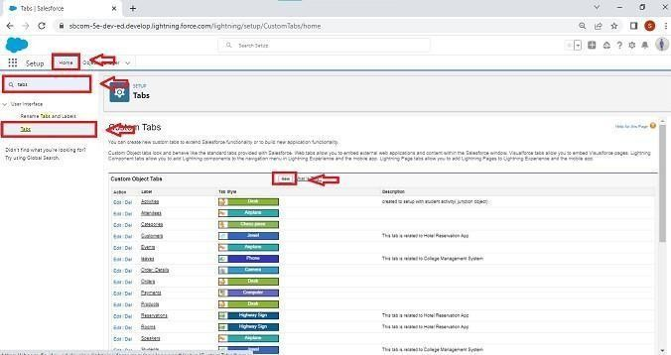

1. Under custom object tabs, click New.

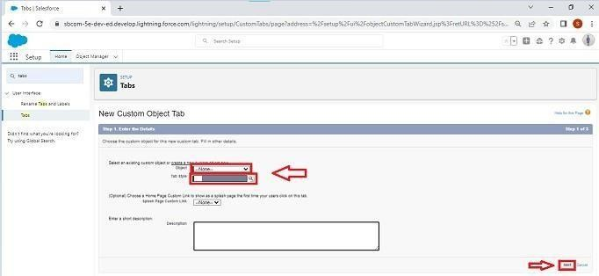

1. For Object, select Recruiter. 4.For Tab Style, select any icon.

5.Leave all defaults as is. Click Next, Next, and Save.

# Creation Of Job Tab

Now create a custom tab.

1. Click on Home tab, enter Tabs in Quick Find and select Tabs.
2. Under custom object tabs, click New.
3. For Object, select Job.
4. For Tab Style, select any icon.
5. Leave all defaults as is. Click Next, Next, and Save.

# Creation Of Candidate Tab

Now create a custom tab.

* 1. Click on Home tab, enter Tabs in Quick Find and select Tabs.
  2. Under custom object tabs, click New.
  3. For Object, select Candidate.
  4. For Tab Style, select any icon.
  5. Leave all defaults as is. Click Next, Next, and Save. 6.

# Creation Of Job Application Tab

Now create a custom tab.

1. Click on Home tab, enter Tabs in Quick Find and select Tabs.
2. Under custom object tabs, click New.
3. For Object, select Job Application.
4. For Tab Style, select any icon.
5. Leave all defaults as is. Click Next, Next, and Save.

# Lightning App

What is an App?

Apps in Salesforce are a group of tabs that help the application function by working together asa unit. It has a name, a logo, and a particular set of tabs. The simplest app usually has just two tabs.

There are 2 types of Salesforce applications:

* + Standard apps: these apps come with every occurrence of Salesforce as default. Community, Call Center, Content, Sales, Marketing, Salesforce Chatter, Site.com, and App Launcher are included in these apps. The description, logo, and label of a standard app cannot be altered.
  + Custom apps: these apps are created according to the needs of a company. They can be made by putting custom and standard tabs together. Logos for custom apps can be changed.

# Create The Job Application Tracking App

* From Setup, enter App Manager in the Quick Find and select App Manager.

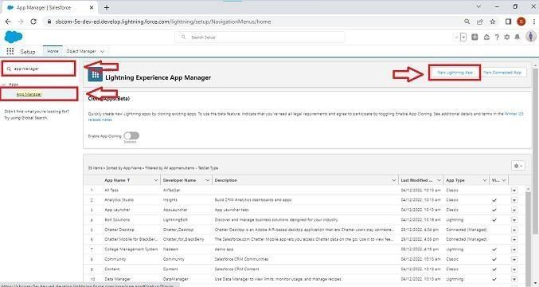

Click New Lightning App. Job Application Tracking as the App Name, then click Next

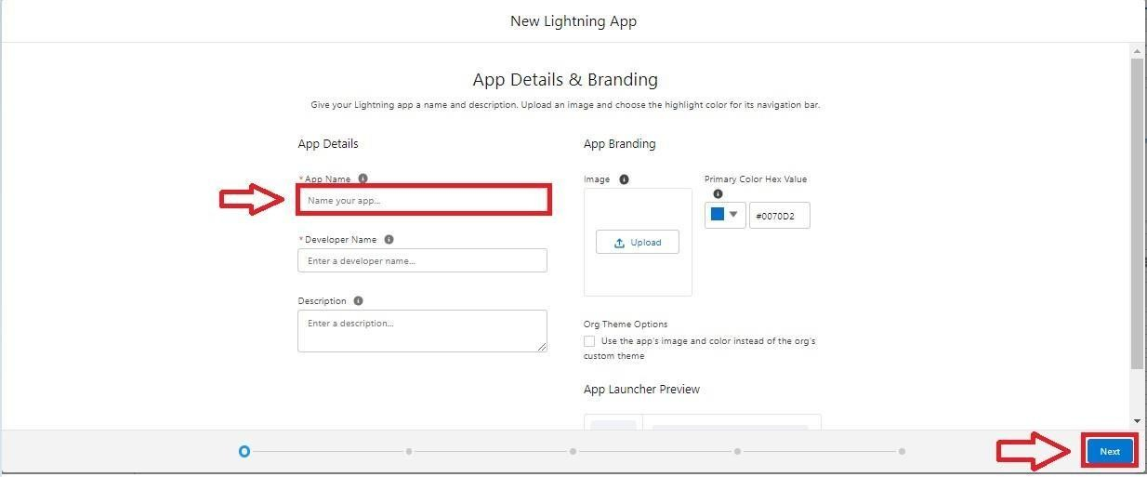

* Under App Options, leave the default selections and click Next.
* Under Utility Items, leave as is and click Next.
* From Available Items, select Recruiters, Jobs,Candidates,Job Application Reports,and Dashboards and move them to Selected Items. Click Next.

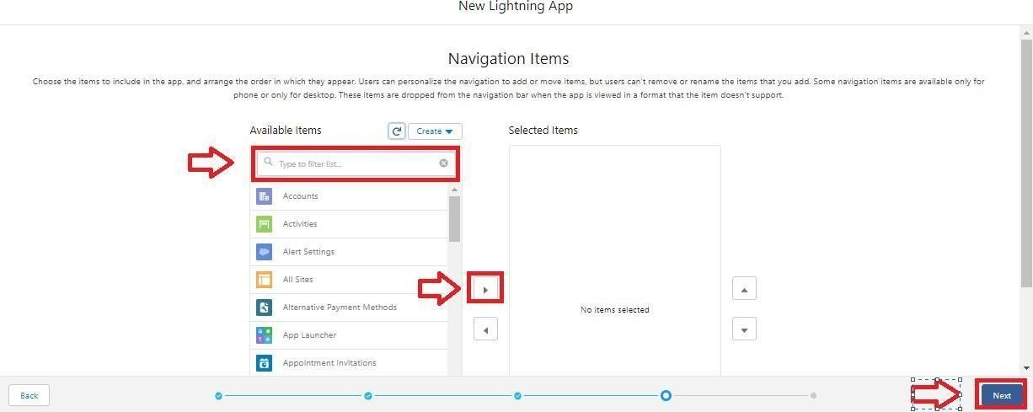

* + From Available Profiles, select System Administrator and move it to Selected Profiles.Click Save & Finish.

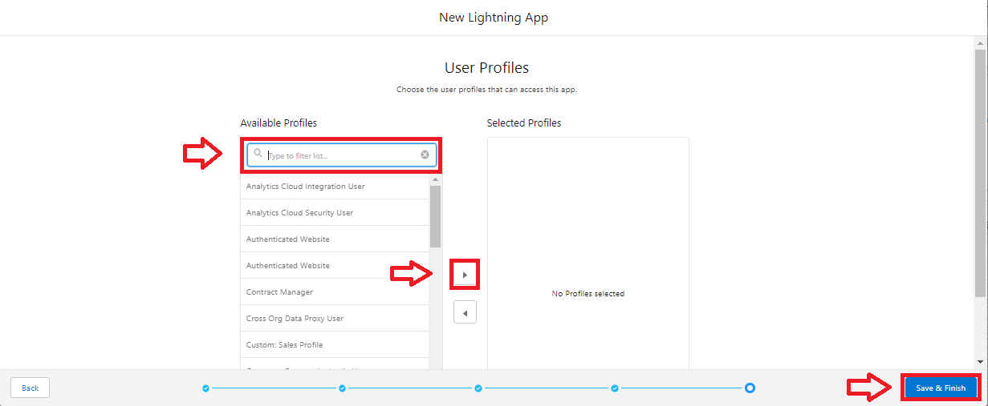

* + To verify your changes, click the App Launcher, type Job Application and select the Job Application app.

Note:

1. App Launcher-Displays available apps.
2. App Name-Displays the current selected app.
3. Navigation menu-Displays the tabs available inside the app.

# Fields And Relationship

What are fields?

Fields in Salesforce represent what the columns represent in relational databases. It can store data values which are required for a particular object in a record.

There are 2 types of fields in salesforce:

* + - Standard fields: There are four standard fields in every custom object that are Created By, Last Modified By, Owner, and the field created at the time of the creation of an object. These fields cannot be deleted or edited and they are always required. For standard objects, the fields which are present by default in them and cannot be deleted from standard objects are standard fields.
    - Custom fields: The Custom fields which are added by the administrator/developer to meet the business requirements of any organization. They may or may not be required.

# Creation Of Fields For The Recruiter Objects

1. click the gear icon and select Setup. This launches Setup in a new tab.
2. Click the Object Manager tab next to Home.
3. Select Recruiter.
4. Select Fields & Relationships from the left navigation, and click New

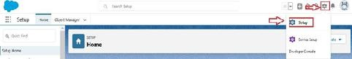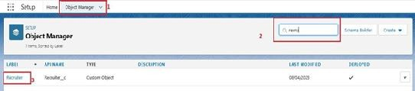

From the sidebar, click Fields & Relationships. Notice that there are already some fields there. Those are the standard fields.

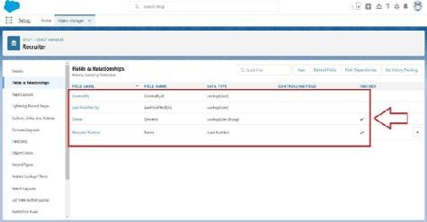

Click New to create a custom field. Tip: Before creating a new field, do a quick search to make sure a similar one doesn’t already exist.

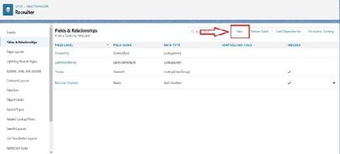

1. Choose the data type as Auto number, click next

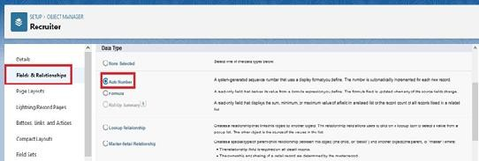

1. Enter field label(Recruiter Number), Display formate RN-{0000} Starting number(1) and click next

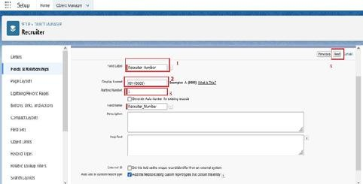

1. Next,Next and Click save.

Now let's create the other fields follow above Activity1 steps 1 to 4 and we must choose the data types of the fields carefully

Select the Text as the Data Type, then click Next. For Field Label, Job Title.

Enter Length (20) Click Next, Next, then Save & New.

* 1. Select the Email as the Data Type, then click Next. For Field Label, Email.
  2. Click Next, Next, then Save & New.
  3. Select the phone as the Data Type, then click Next. For Field Label, Phone.
  4. Click Next, Next, then Save & New.

# Creation Of Fields For The Job Objects

## Follow the above steps from 1 to 4 of activity 1

1. Select the Auto number as the Data Type, then click Next.

For Field Label, enter Job Application Id., Display format (J-{000}) starting number (001) Click Next, Next, then Save & New

1. Select the Text area as the Data Type, then click Next. For Field Label, Description.

Click Next, Next, then Save & New.

1. Select the **Text** as the Data Type, then click Next. For Field Label, enter Location, and length (20) Click Next, Next, then Save & New

# Creation Of Master-Detail Relationship For Job Object

1. From Setup, go to Object Manager
2. On the sidebar, click Fields & Relationships. 3.Click New.

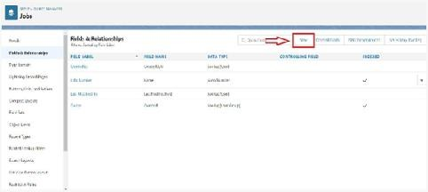

1. Choose Master-detail Relationship and click Next

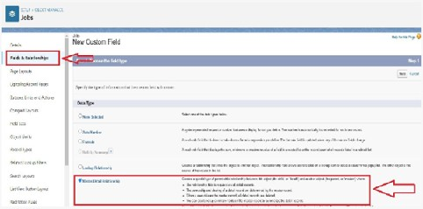

1. Choose the related object(Recruiter) and select that object.

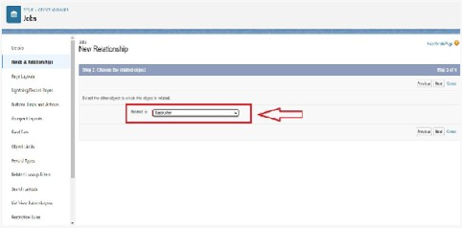

1. Enter the label name(Recruiter Name)

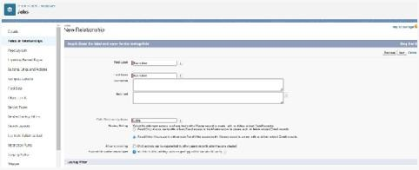

1. Click Next, Next, and Save

# Creation Of Fields For The Candidate Object

Follow the above steps from 1 to 4 of activity 1

1. Select the Text area as the Data Type, then click Next. For Field Label, Address, Click Next, Next, then Save & New.
2. Select the Email as the Data Type, then click Next. For Field Label, enter Email. Click Next, Next, then Save & New.
3. Select the Phone as the Data Type, then click Next. For Field Label, enter Phone. Click Next, Next, then Save & New
4. Select Picklist as the Data Type and click Next. For Field Label enter Education. Select Enter values, with each value separated by a new line and enter these values: Graduation ,

Post-Graduation. Click Next, Next, then Save & New.

1. Select the Text area as the Data Type, then click Next. For Field Label, enter Skill Set.

Click Next, Next, then Save & New

# Create Picklist Fields On Candidate Object

* + Click on the gear icon and then select Setup.
  + Click on the object manager tab just beside the home tab.
  + After the above steps, Select candidate Object
  + Now Select Fields and relationships from setup menu of the candidate object.
  + Click new and select Picklist fields ????next and enter label name(State) and select enter values option

(Rajasthan, UP, MP, Punjab), next, next and Save.

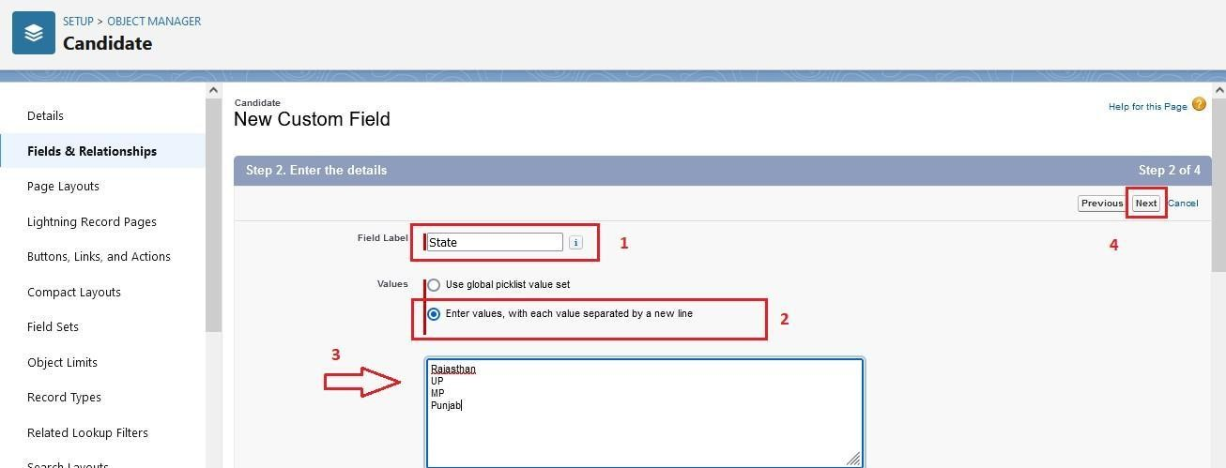

Follow same above steps for create city and Education Picklist fields with their values.

1. Select Picklist as the Data Type and click Next. For Field Label name City

And Select Enter values, with each value separated by a new line and enter these values

(Jaipur, Jalandhar, Lucknow, Bhopal), next, next and Save.

1. Select Picklist as the Data Type and click Next. For Field Label enter Education.

Select Enter values, with each value separated by a new line and enter these values: Graduation ,

Post-Graduation. Click Next, Next, then Save & New

# Create Field Dependency (On Candidate Object)

Create a dependency between these two picklists, so that when a state is selected, only respective Values are available.

The below steps will assist you in creating Field Dependencies.

* + Click on the gear icon and then select Setup.
  + Click on the object manager tab just beside the home tab.
  + After the above steps, Select Candidate Object
  + Now Select Fields and relationships from setup menu of the Candidate object.
  + Click Field Dependencies.
  + Click New.
  + Select State as the Controlling Field and select City as the Dependent Field.
  + Click Continue.
  + Select the appropriate Value in each column by double-clicking them.
  + For Ex. Rajasthan - Jaipur
  + Click Include Values. And it is also same for UP, MP& Punjab with its city.
  + Click Preview, then test the dependency by selecting different State and viewing the associate Values available for Particular state.
  + Click Close to close the preview window.
  + Click Save.

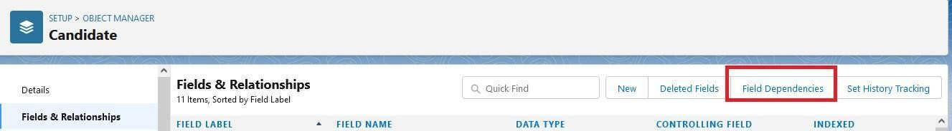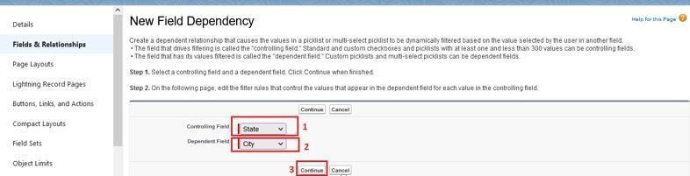

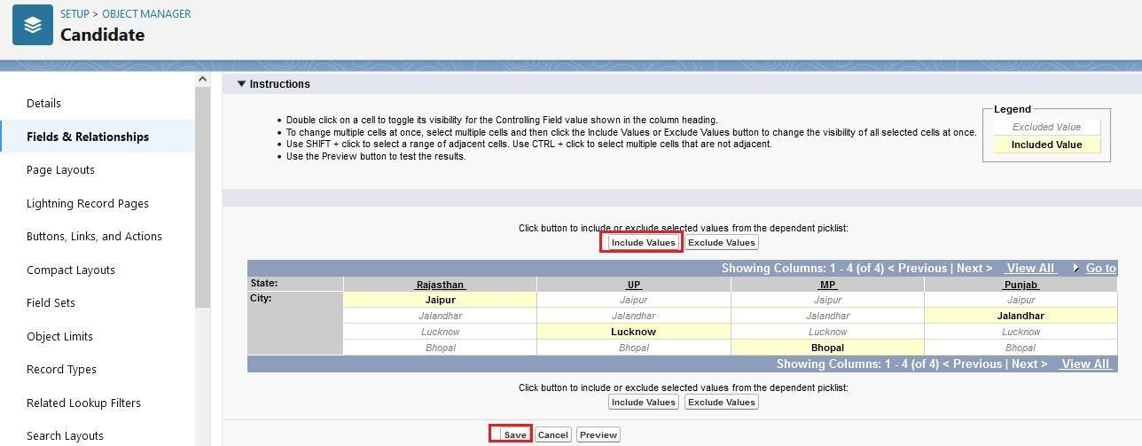

# Creation Lookup Relationship For The Job Application Objects

## Let’s create two lookup relationship on job application object First lookup relationship From Setup, go to Object Manager

* + On the sidebar, click Fields & Relationships.
  + Select Lookup relationship & click next
  + Choose the related object as Candidate & click next
  + Give the field label(Candidate name) & click next, next, next and Save

## Second lookup relationship

* + From Setup, go to Object Manager
  + On the sidebar, click Fields & Relationships.
  + Select Lookup relationship & click next
  + Choose the related object as Job & click next
  + Give the field label(Job Name) & click next, next, next and Save